**login and register session in core php**

**introduction**

login and register session

**create database name queries**

login

CREATE DATABASE login;

**table name queries**

CREATE TABLE loginsys(

id int(11)AUTO_INCREMENT,

**username** char(30) NOT NULL,

**email** char(30) NOT NULL,

**password** char(30) NOT NULL,

**create_datetime datetime** NOT NULL,

PRIMARY KEY(id)

);

**Pages**

**Login.php**

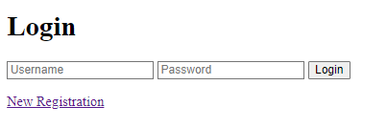

**Register.php**

